# SMD Crystal Oscillators- CMOS Output

*Oscillators*

*Series*

*Think of Frequency Think of*

*come visit our site [http://www.txccorp.com](http://www.txccorp.com/)*

# 3.2 x 2.5 x 1.0 mm 7X Series

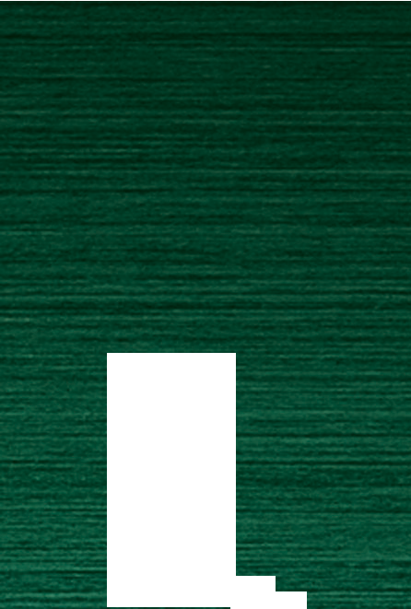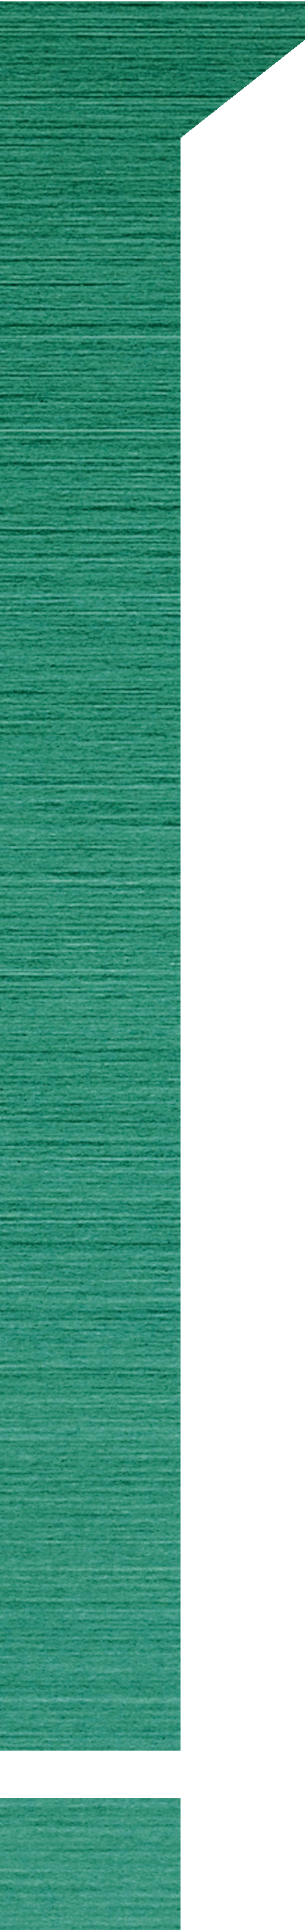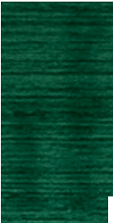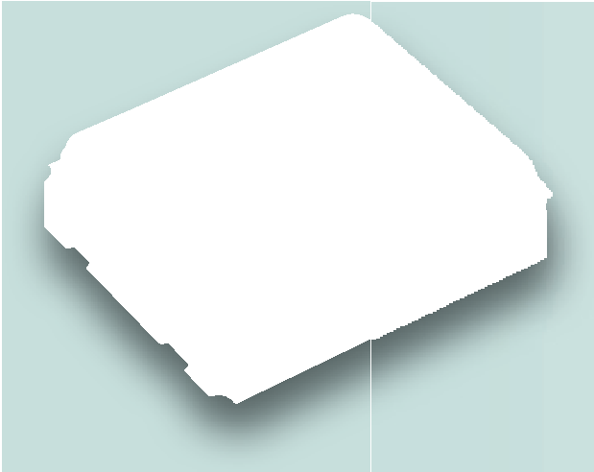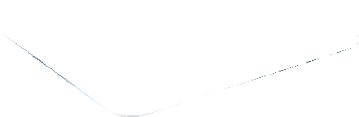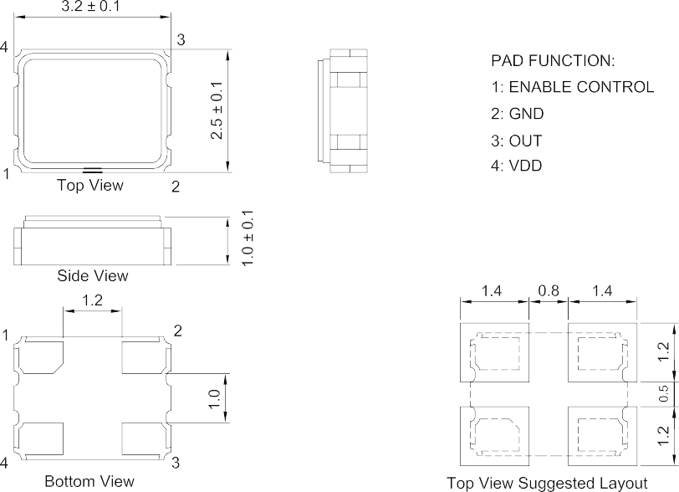

Features

．Ultra Small SMD seam sealed clock crystal oscillator units.

．For applications in WLAN, Bluetooth, DSC, DSL and other IT product.

．Tri-state function available.

．RoHS Compliant / Pb Free.

## Electrical Specifications

**Item / Type 7X**

Remark : Speciﬁcation subject to change without prior notice. Please conﬁrm with our sales. [http://www.txccorp.com](http://www.txccorp.com/)



|  |  |  |
| --- | --- | --- |
| Output Type | CMOS | |
| Output Load | 15 pF , or specify | |
| Oscillation Mode | Fundamental / 3rd Overtone | |
| Supply Voltage | 1.8 V | 2.5 V , 2.8 V , 3.3 V |
| Frequency Range | 1 ~ 125 MHz | |
| Frequency Stability | ± 25 ppm , ± 50 ppm | |
| Operating Temperature Range | - 10 ~ + 70 ℃ , - 40 ~ + 85 ℃ | |
| Storage Temperature Range | - 55 ~ + 125 ℃ | |
| Voltage Vol ( Max. ) / Voh ( Min. ) | 0.1 VDD / 0.9 VDD | |
| Rise ( Tr ) / Fall ( Tf ) Time | 8 ns Max. | |
| Supply Current | 15 mA Max. | |
| Symmetry | 45 ~ 55 % | |
| Start-up Time | 5 ms Max. | |
| Phase Jitter ( 12 KHz ~ 20 MHz ) | 1 ps Max. | |
| Aging ( at 25 ℃ ) | ± 3 ppm / year Max. | |

## Dimensions

Units: mm

## 44

