Approved by: Checked by: Issued by:

***SPECIFICATION***

# PRODUCT: SAW Resonator

**M O D E L: JHC-R433(SMD-2) 433.920**

The TR433A is a true one- port ， surface- acoustic- wave( SAW) resonator in a low- profile D -11 case. It provides reliable ， fundamental- mode ， quartz frequency stabilization of fixed- frequency transmitters operating at 433.92 MHz.

1. **Package Dimension** (SMD-2)

|  |  |
| --- | --- |
| **Pin** | **Connection** |
| 1 | Input |
| 2 | Case Ground |
| 3 | Output |

1. 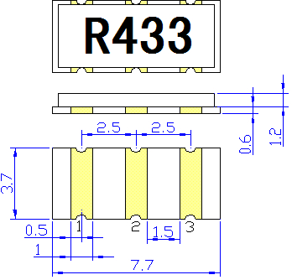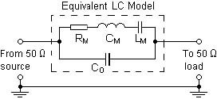**Marking 3.Equivalent LC Model and Test Circuit**

**R433**

Color:White

**5. Typical Frequency Response 6.Temperature Characteristics**

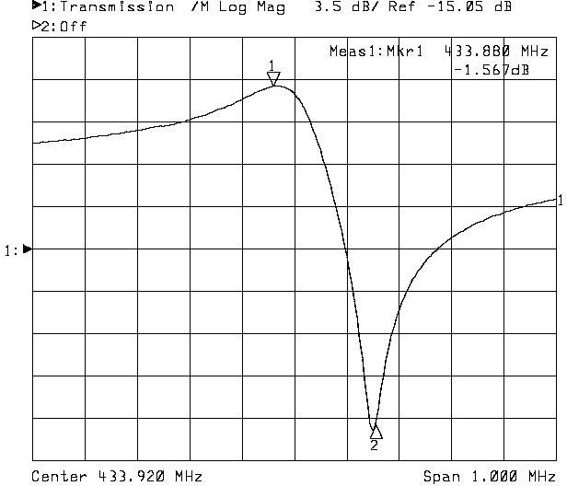 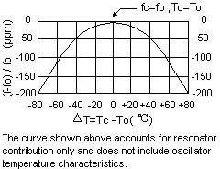

**7. Performance**

7-1.Maximum Rating

|  |  |  |
| --- | --- | --- |
| **Rating** | **Value** | **Units** |
| CW RF Power Dissipation | +10 | dBm |
| DC Voltage Between Any Two Pins | ±30V | VDC |
| Case Temperature | -40 to +85 | ℃ |

7-2.Electronic Characteristics

|  |  |  |  |  |  |  |
| --- | --- | --- | --- | --- | --- | --- |
| **Characteristic** | | **Sym** | **Minimum** | **Typical** | **Maximum** | **Units** |
| Center Frequency (+25℃) | Absolute Frequency | fC | 433.845 |  | 433.995 | MHz |
| Tolerance from 433.920 MHz | ∆ fC |  | ±75 |  | kHz |
| Insertion Loss | | IL |  | 1.5 | 1.8 | dB |
| Quality Factor | Unloaded Q | QU |  | 15974 |  |  |
| 50 Ω Loaded Q | QL |  | 1900 |  |  |
| Temperature Stability | Turnover Temperature | TO | 25 | 40 | 55 | ℃ |
| Turnover Frequency | fO |  | fc |  | kHz |
| Frequency Temperature Coefficient | FTC |  | 0.037 |  | 2  ppm/℃ |
| Frequency Aging Absolute Value during the First Year | | |fA| |  | ≤10 |  | ppm/yr |
| DC Insulation Resistance Between Any Two Pins | |  | 1.0 |  |  | MΩ |
| RF Equivalent RLC Model | Motional Resistance | RM |  | 19 | 23 | Ω |
| Motional Inductance | LM |  | 79.137 |  | µH |
| Motional Capacitance | CM |  | 1.8019 |  | fF |
| Pin 1 to Pin 2 Static Capacitance | CO |  | 1.9 |  | pF |

 **CAUTION: Electrostatic Sensitive Device. Observe precautions for handling!**

### NOTES:

1. Frequency aging is the change in fC with time and is specified at +65℃or less. Aging may exceed the specification for prolonged temperatures above +65℃. Typically, aging is greatest the first year after manufacture, decreasing in subsequent

years.

1. The center frequency, fC, is the frequency of minimum IL with the resonator in the specified test fixture in a 50 Ω test system with VSWR ≤ 1.2: 1. Typically, foscillator or ftransmitter is less than the resonator fC.
2. Typically, equipment utilizing this device requires emissions testing and government approval, which is the responsibility of the equipment manufacturer.
3. Unless noted otherwise, case temperature TC=+25℃±2℃.
4. The design, manufacturing process, and specifications of this device are subject to change without notice.
5. Derived mathematically from one or more of the following directly measured parameters: fC, IL, 3 dB bandwidth, fC versus TC , and CO.
6. Turnover temperature, TO, is the temperature of maximum (or turnover) frequency, fO,The nominal center frequency at any

2

case temperature, TC, may be calculated from: f = fO［1-FTC (TO-TC) ］.Typically, oscillator TO is 20℃ less than the specified

resonator TO.

1. This equivalent RLC model approximates resonator performance near the resonant frequency and is provided for reference only. The capacitance CO is the measured static (nonmotional) capacitance between either pin 1 and ground or

pin 2 and ground .The measurement includes case parasitic capacitance with a floating case. For usual grounded case applications (with ground connected to either pin 1 or pin 2 and to the case), add approximately 0.25 pF to CO.