**®** **珠海三语电子科技有限公司**

**ZHU HAI SANYU ELECTRONIC TECHNOLOGY CO.,LTD**

**[WWW.SANYUDZ.COM](http://WWW.SANYUDZ.COM) 0756-6242612 andymiao@sanyudz.com**

|  |
| --- |
| Approved by:  RoHS |
| Checked by: |
| Issued by: |

Surface-Acoustic-Wave Resonator

SPECIFICATION

# R315T2

SMD 7.5X3.5

### *Low Series Resistance* Quartz Stability

315.00 MHz SAW

Resonator

***Rugged, Hermetic, Low-profile SMD7.5X3.5 Case***

The R315T2 is a true one-port, surface-acoustic-wave (SAW) resonator in a surface-mount epoxy board. It provides reliable, fundamental-mode, quartz frequency stabilization i.e. in transmitters or local oscillators operating at 315.000 MHz.

**Absolute Maximum Ratings**

|  |  |  |
| --- | --- | --- |
| **Rating** | **Value** | **Units** |
| CW RF Power Dissipation (See Typical Test Circuit) | +0 | dBm |
| DC Voltage Between Any Two Pins (Observe ESD Precautions) | ±30 | VDC |
| Case Temperature | -40 to +85 | ℃ |

**Electrical Characteristics**

|  |  |  |  |  |  |  |
| --- | --- | --- | --- | --- | --- | --- |
| **Characteristics** | **Sym** | **Notes** | **Minimum** | **Typical** | **Maximum** | **Units** |
| Center Frequency (+25℃) Absolute Frequency  Tolerance from 315.000MHz | fc | 2,3,4,5 | 314.925 |  | 315.075 | MHz |
| Δfc |  |  | ±75 | KHz |
| Insertion Loss | IL | 2,5,6 |  | 1.5 | 2.2 | dB |
| Quality Factor Unloaded Q  50Ωloaded Q | QU | 5,6,7 |  | 13.300 |  |  |
| QL |  | 2.000 |  |  |
| Temperature Stability Turnover Temperature  Turnover Frequency  Frequency Temperature Coefficient | TO | 5,7,8 | 10 | 25 | 40 | ℃ |
| fO |  | fc |  | KHz |
| FTC |  | 0.037 |  | ppm/℃2 |
| Frequency Aging Absolute Value during the First Year | IfAI | 1 |  | ≦10 |  | ppm/yτ |
| DC Insulation Resistance between Any Two Pins |  | 5 | 1.0 |  |  | MΩ |
| RF Equivalent RLC Model Motional Resistance  Motional Inductance Motional Capacitance  Pin 1 to Pin 2 Static Capacitance | RM | 5,7,9 |  | 19 | 29 | Ω |
| LM |  | 127.677 |  | μH |
| CM |  | 1.99943 |  | pF |
| CO | 5,6,9 | 2.3 | 2.6 | 2.9 | pF |
| Transducer Static Capacitance | CP | 5,6,7,9 |  | 2.3 |  | pF |
| Test Fixture Shunt Inductance | LTEST | 2,7 |  | 100 |  | nH |
| Lid Symbolization (in Addition to Lot and/or Date Code | R315T2 | | | | | |

**CAUTION: electrostatic Sensitive Device, Observe precautions for handling. Notes:**

1. Frequency aging is the change in fC with time and is specified at +65℃ or less. Aging may exceed the specification for prolonged temperatures above +65℃. Typically, aging is greatest the first year after manufacture, decreasing significantly in subsequent years.
2. The center frequency, fC, is measured at the minimum insertion loss point, ILMIN with the resonator in the 50Ω test system(VSWR≦1.2:1).The shunt inductance, LTEST, is turned for parallel resonator with CO at fc. Typically, fOSCILLATOR or fTRANSMITTER is less than the resonator fc.
3. One or more of following United States patents apply:4,454,488 and 4,616,197 and others pending.
4. Typically, equipment designs utilizing this device require emissions testing and government approval, which is the responsibility of the equipment manufacturer.
5. Unless noted otherwise, case temperature Tc=25℃±2℃.
6. The design, manufacturing process, and specifications of this device are subject to change without notice.
7. Derived mathematically from one or more of the following directly measured parameter: fc, IL, 3dB bandwidth, fc versus Tc, and Co.
8. Turnover temperature, To , is the temperature of maximum (or turnover) frequency, fo. The nominal frequency at any case temperature, Tc. may be calculated from:

f=fo [1-FTC(To-Tc)2]. Typically, *oscillator* To is 20℃ less than the specified *resonator* To.

1. This equivalent RLC model approximates resonators performance near the resonant frequency and is provided for reference only. The capacitance Co is the static (non- motional) capacitance between pin 1 and pin 2 measured at low frequency (10MHz) with a capacitance meter. The measurement includes case parasitic capacitance with a floating case. For usual grounded case applications (with ground connected to either pin 1 or pin 2 and to the case), add approximately 0.25pF to Co.

**Electrical Connections**

This one-port, two-terminal SAW resonator is bi-directional. The terminals are interchangeable with the exception of circuit board layout.

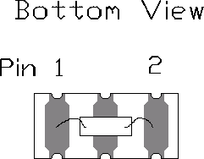

|  |  |
| --- | --- |
| **Pin** | **Connection** |
| 1 | Terminal 1 |
| 2 | Terminal 2 |

## Typical Test Circuit

The test circuit inductor, LTEST, is turn to resonate with the static capacitance, Co at Fc.

**Electrical Test:**

**Power Test:**

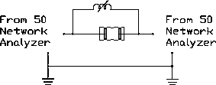

**Typical Application Circuits**

**Typical Low-Power Transmitter Application:**

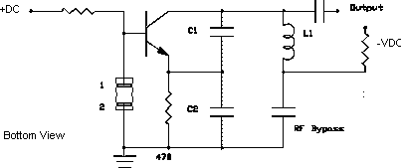

**Typical Local Oscillator Application:**

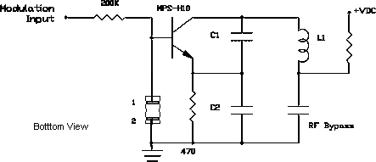

**Temperature Characteristics**

The curve shown on the right accounts for resonator contribution only and does not include oscillator temperature characteristics.

## Equivalent LC Model

The following equivalent LC model is valid near resonance:

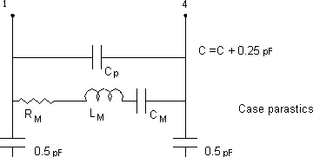

## Case Design

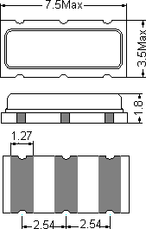

**Frequency Response**

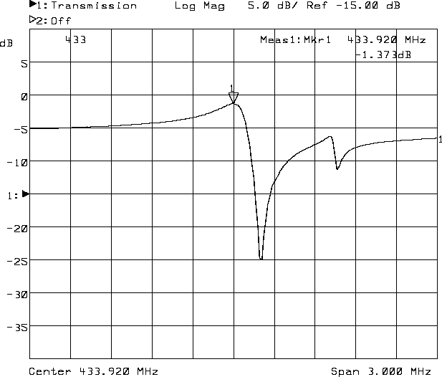

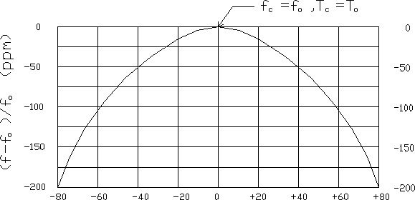

**Taping structure**

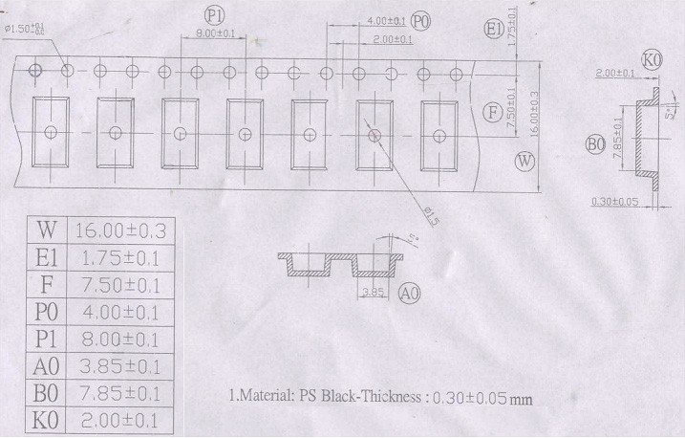Componet load per 7’ reel: 1000pcs