|  |  |
| --- | --- |
| HOSONIC |  |
| **RoHS Compliant** | |

|  |  |
| --- | --- |
| **Customer** |  |
| **Production Name** | **SMD CRYSTAL 5.0*3.2** |
| **Customer P/N** | **N/A** |
| **P/N** | **5032-SMD24.000M12PF** |
| **Revision** | **A** |
| **Print Date** | **2017-9-23** |

|  |  |  |
| --- | --- | --- |
| **Drawn** | **Checked** | **Approved** |
|  |  |  |

|  |  |  |  |  |  |
| --- | --- | --- | --- | --- | --- |
| HOSONIC | |  | | | |
| * **ELECTRICAL PARAMETERS** | | | | | |
| **谐振器产品技术指标** | | | **Min** | **Max** | **Units** |
| 1.Holder Type(型号规格) | | | SEAM 5.0*3.2 | | |
| 2.Mode of Oscillation（振动模式） | | | Fundamental | | |
| 3.Frequency（标称频率） | | | 24.000000 | | MH**Z** |
| 4.Load Capacitance (CL)（负载电容） | | | 12 | | pF |
| 5.Drive Level（激励功率） | | | 100 | | uw |
| 6.Equivalent Resistance（谐振电阻） | | |  | 100 | Ω |
| 7.Shunt Capacitance (Co)（静态电容） | | | 0 | 7 | pF |
| 8.Motional Capacitance (C1) (动态电容) | | | N/A | | fF |
| 9.Frequency Tolerance at 25℃（调整频差） | | | -10 | +10 | ppm |
| 10.Stability over operation temperance（温度频差） | | | ± 30 | | ppm |
| 11.Insulation Resistance (at DC 100V)（绝缘电阻） | | | 500 |  | MΩ |
| 12.Operating Temperature Range（工作温度范围） | | | -40 | 85 | ℃ |
| 13.Storage Temperature Range（储存温度范围） | | | -40 | 85 | ℃ |
| 14.Aging（老化率） | | | ± 5 | | ppm/year |
| 15.DLD2 | N/A | |  | N/A | Ω |
| 16.FLD2 |  | N/A | ppm |
| 17.RLD2 |  | N/A | Ω |
| 18.SPDB | N/A | |  | N/A | db |
| 19.Other(其它) | | | N/A | | |
| **OUTLINE DIMENSIONS(UNIT:mm）外形尺寸（单位：mm）** | | | | | |

|  |  |  |  |
| --- | --- | --- | --- |
| HOSONIC |  | | |
| * **SUGGESTED REFLOW PROFILE （回流焊曲线图） Total time:200sec.Max. （总时间：200秒 最大） Solder melting point:220℃（熔点220 ℃ ）** | | | |
| **Profiles Feature（特性）** | | | **Pb-Free Assembly** |
| **Average Ramp-up Rate(Ts max to Tp)平均升温速度** | | | **3℃/second Max** |
| **Preheat**   * **Temperature Min (Ts min)** * **Temperature Max (Ts max)** * **Time (ts min to ts max )** | | **预热**  **最低温度最高温度**  **从最低到最高时间** | **125℃**  **200℃**  **(60～180) seconds** |
| **Time maintained above**   * **Temperature(T1)** * **Time(tp)** | | **维持上述时间温度**  **时间** | **217℃**  **(60～150) seconds** |
| **Peak/Classification Temperature(Tp) 最高点温度** | | | **260 ℃** |
| **Time within 5℃ of actual Peak Temperature(tp)** | | **高温维持时间** | **(20～40) seconds** |
| **Ramp-down rate** | | **降温速度** | **6℃/second max** |
| **Time 25℃ to Peak Temperature** | | **从25℃到最高温度的时间** | **8 minutes max** |
| **Suggest reflow times** | | **建议 reflow次数** | **3 Times max** |
|  | | | |

HOSONIC

HOSONIC

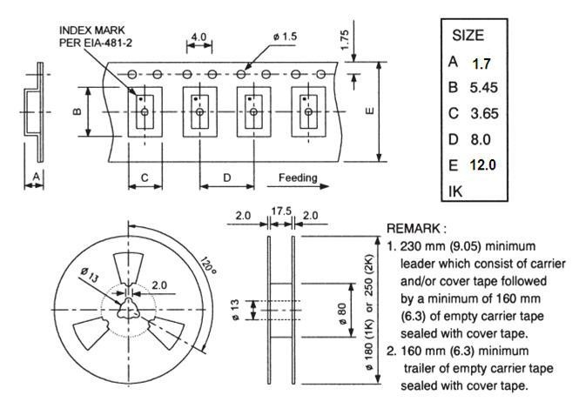

* **PACKING（包装） 1Kpcs/REEL**

|  |  |  |  |
| --- | --- | --- | --- |
| HOSONIC | |  | |
| * **RELIABILITY SPECIFICATIONS（信赖度试验）** | | | |
| **No** | **Test Item（测试项目）** | **Test Conditions（测试条件）** | **Reference（参考）** |
| **1** | **High Temperature High Humidity Storage (高温、高湿、储存)** | **Temperature: 85℃±3℃ 温度: 85℃±3℃**  **Relative Humidity:85%RH 相 对 湿 度 : 85%RH Time: 96 Hours**  **时间: 96小时** | **JIS C5023** |
| **2** | **High Temperature Storage (高温储存)** | **Temperature: 125℃±3℃ 温度:125℃±3℃**  **Time: 96 Hours**  **时间:96 小时** | **MIL-STD-883E**  **Method 1005.8** |
| **3** | **Low Temperature Storage (低温储存)** | **Temperature: -40℃±3℃ 温度：-40℃±3℃**  **Time: 96Hours**  **时间：96小时** | **MIL-STD-883E**  **Method 1013** |
| **4** | **Thermal Shock (温度冲击)** | **Temperature1:-55℃±5℃ 温 度 1:-55℃±5℃ Temperature2:85℃±5 ℃ 温度2: 85℃±5 ℃**  **Temperature change between T1 and T2 5 min T1和T2温度在5分钟内改变**  **10cycles maintain T1 and T2 for 30 minutes each mone**  **每次循环30分钟共10次** | **MIL-STD-202F**  **Method 107 Condition A** |
| **5** | **RESISTANCE TO SOLDER HEAT**  **(耐焊接热)** | **Solder Temperature: 260℃±5℃ 焊槽温度:260℃±5℃**  **Time: 10±1 Seconds**  **时间: 10±1秒** | **MIL-STD-202F**  **Method 210E** |
| **6** | **Solderability(可焊性)** | **The solder pot temperature is 245±5℃ , dwell time 5±0.5s**  **245±5℃焊锡槽浸润5±0.5秒** | **J-STD-002B** |
| **7** | **Drop Test (落下试验)** | **3 Times Free Fall from 75cm height table to 3cm thickness hard wood board**  **从75cm高度3次跌落到3cm厚硬质木板上** | **JIS C6701** |
| **8** | **MECHANICAL SHOCK**  **(机械冲击)** | **Half sine wave,1000 G**  **半正弦波,加速度1000G 3 Times for all 3 directions**  **X、Y、Z 三个相互垂直方向各三次** | **MIL-STD-202F**  **Method 213B** |
| **9** | **Vibration**  **(机械振动)** | **Frequency Range: 10Hz～55Hz**  **频率范围: 10Hz～55Hz Amplitude: 0.75mm**  **振幅：0.75mm**  **2 Hours in each direction, total 6 Hours**  **X、Y、Z 三个相互垂直方向各振动2小时** | **MIL-STD-883E**  **Method 2007.3** |
| **10** | **Leakage Test (气密性)** | **Take measurements with a helium Leakage detector**  **氦质检漏**  **Leakage Rate≤1×10-3Pa cm3/s**  **漏率≤1×10-3Pa cm3/s** | **MIL-STD-883E** |